Louisiana Purchase Summary
For this assignment, you will write a 2-paragraph summary using the guided highlight we completed in class.
Paragraph 1- Begin by telling what the Louisiana Purchase is. Then describe one or two events that led to the Louisiana Purchase- be sure to cite evidence from the reading selection. Reference subtitles: The Land-Completing the Deal
Paragraph 2- Summarize the purchase and the benefits of it to the United States. Be sure you are supporting your thoughts with ideas from the reading selection. Reference subtitles: The Legacies

Your response should be no more than one page in length. You will be scored according to the following rubric:
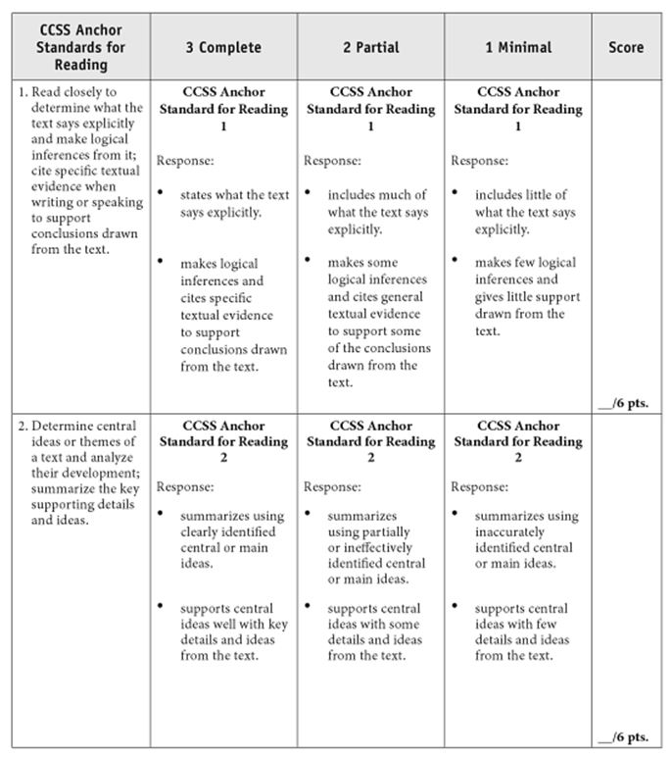
You may use the back or attach this to your paper when complete. This assignment is due at the beginning of class on Tuesday, Jan. 13, 2016.

